**Practical 8**

**Aim:**- Implementation and analysis of Classification algorithms like

1. Naive Bayesian,

2. K-Nearest Neighbor.

**Theory:-**

Naive Bayes

• Based on the Bayes theorem

• Predicts based on probabilities from training data

P(B|A) = P(A|B) P(B)/P(A) Gives posterior probability of ‘B’ given ‘A’ using prior probability of ‘B’ prior probability of ‘A’ and conditional probability of ‘A’ given ‘B’

•Takes two step approach

– Calculates the posterior probability of the Class given the input - for every class

– Assigns the class with higher posterior probability

• More suited when dimensionality of input is high the - widely used for document classification

• Also good for the multiclass classifications

• Works well with less datasets also, but the assumption that predictor variables are independent should hold ##NaiveBayes .

**R Commands:-**

setwd(“E:/R Orientation”)

library("caret")

library(ggplot2)

data(iris)

head(iris)

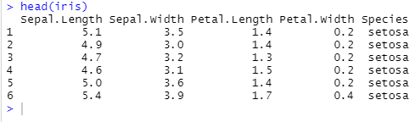

unique(iris$Species)

pairs(iris[1:4], main="Iris Data (red=setosa,green=versicolor,blue=virginica)", pch=21,

bg=c("red","green3","blue")[unclass(iris$Species)])

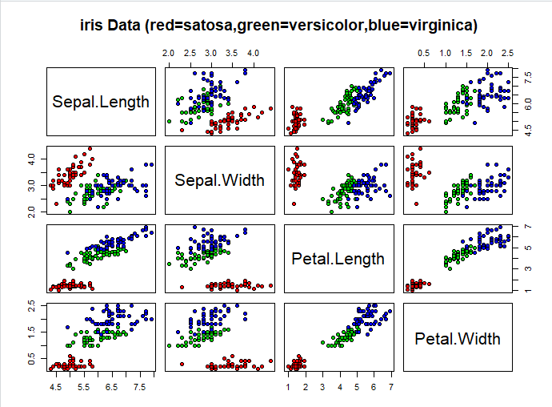

index = sample(nrow(iris), floor(nrow(iris) * 0.7))

train = iris[index,] test = iris[-index,]

xTrain = train[,-5]

yTrain = train$Species

xTest = test[,-5]

yTest =test$Species

model = train(xTrain,yTrain,'nb',trControl=trainControl(method='cv',number=10))

model

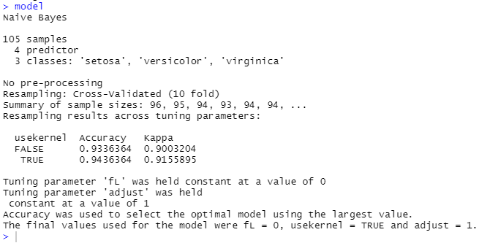

prop.table(table(predict(model$finalModel,xTest)$class,yTest))

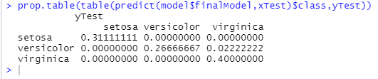

K-Nearest Neighbor

df <- data(iris)

head(iris)



ran <-sample(1:nrow(iris), 0.9 * nrow(iris))

nor <-function(x) { (x - min(x))/(max(x)-min(x)) }

iris_norm <-as.data.frame(lapply(iris[,c(1,2,3,4)], nor))

summary(iris_norm)

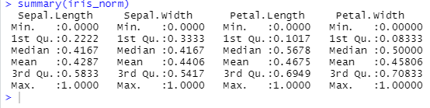

iris_train <-iris_norm[ran,]

iris_test <-iris_norm[-ran,]

iris_target_category <- iris[ran,5]

iris_test_category <- iris[-ran,5]

library(class)

pr <- knn(iris_train,iris_test,cl=iris_target_category,k=13)

tab <-table(pr,iris_test_category)

accuracy <- function(x){sum(diag(x)/(sum(rowSums(x)))) * 100}

accuracy(tab)

